**Mobile Application Development**

**Assignment-(03)**

Name: Shabuddin Mozumder Shagar

USN : 20BTRSE063

Branch: SE

Question: Demonstrate a Example to show how to work with Menu's (Options, Context and Pop up) in Android Environment.

Solutions:

**Options MenuBar:**

**Xml code:**

<?xml version="1.0" encoding="utf-8"?>

<menu xmlns:android="http://schemas.android.com/apk/res/android"

xmlns:app="http://schemas.android.com/apk/res-auto">

<item android:id="@+id/item1"

android:icon="@drawable/ic_icon"

android:title="Item 1"

app:showAsAction="ifRoom"/>

<item android:id="@+id/item2"

android:title="Item 2"

app:showAsAction="never"/>

<item android:id="@+id/item3"

android:title="Item 3"

app:showAsAction="never">

<menu>

<item android:id="@+id/subitem1"

android:title="Sub Item 1" />

<item android:id="@+id/subitem2"

android:title="Sub Item 2"/>

</menu>

</item>

</menu>

**JAVA CODE:**  
package com.shabuddinshagar.menubardemo;

import androidx.annotation.NonNull;

import androidx.appcompat.app.AppCompatActivity;

import android.os.Bundle;

import android.view.Menu;

import android.view.MenuItem;

import android.widget.Toast;

public class OptionMenuBar extends AppCompatActivity {

@Override

protected void onCreate(Bundle savedInstanceState) {

super.onCreate(savedInstanceState);

setContentView(R.layout.activity_option_menu_bar);

}

@Override

public boolean onCreateOptionsMenu(Menu menu) {

getMenuInflater().inflate(R.menu.option_menubars,menu);

return true;

}

@Override

public boolean onOptionsItemSelected(@NonNull MenuItem item) {

int item_id=item.getItemId();

switch(item_id){

case R.id.item1:

Toast.makeText(this, "Item 1 clicked", Toast.LENGTH_SHORT).show();

return true;

case R.id.item2:

Toast.makeText(this, "Item 2 clicked", Toast.LENGTH_SHORT).show();

return true;

case R.id.item3:

Toast.makeText(this, "Item 3 clicked", Toast.LENGTH_SHORT).show();

return true;

case R.id.subitem1:

Toast.makeText(this, "Sub Item 1 clicked", Toast.LENGTH_SHORT).show();

return true;

case R.id.subitem2:

Toast.makeText(this, "Sub Item 2 clicked", Toast.LENGTH_SHORT).show();

return true;

default:

return super.onOptionsItemSelected(item);

}

}

}

**Design:**

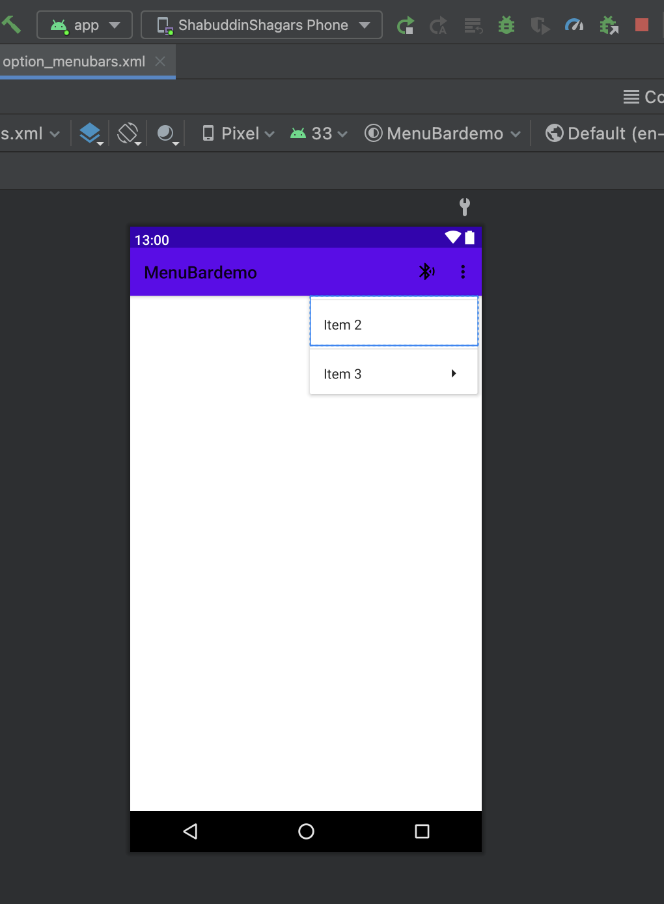

**OUTPUT:**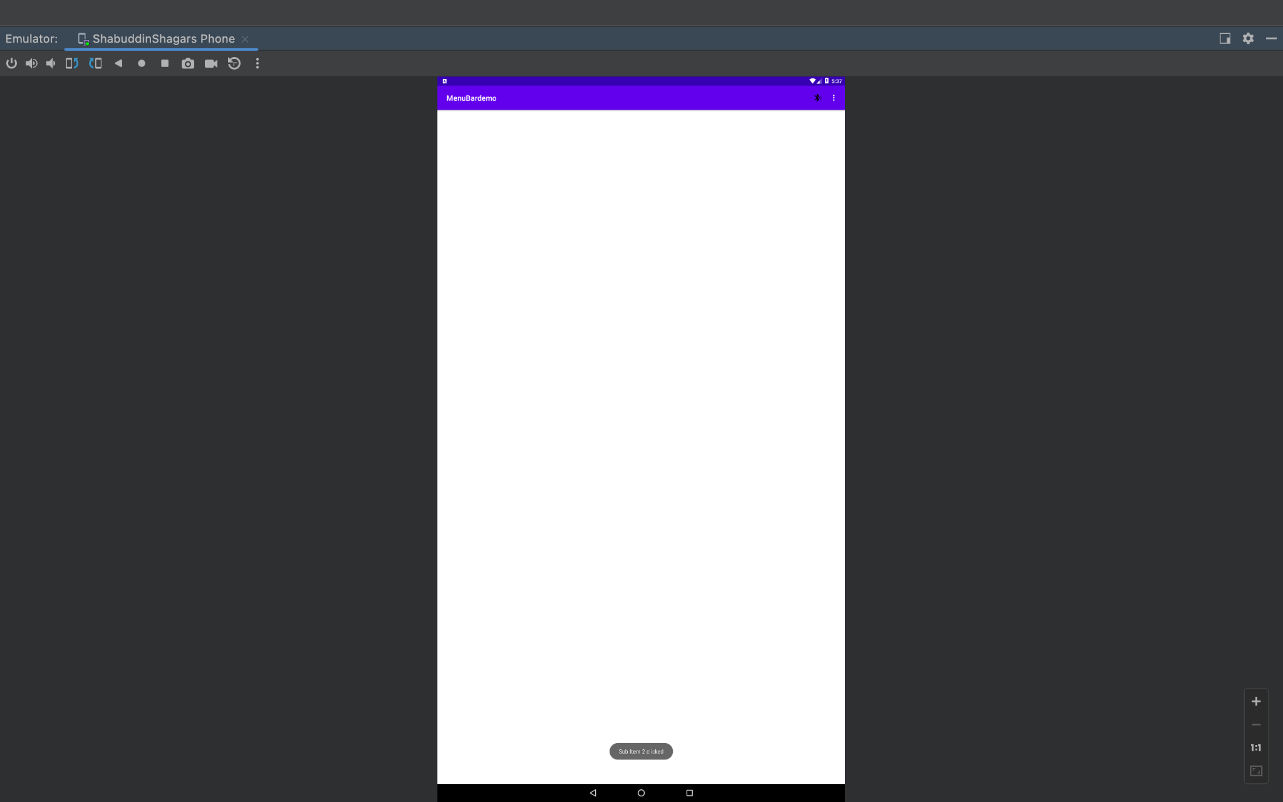

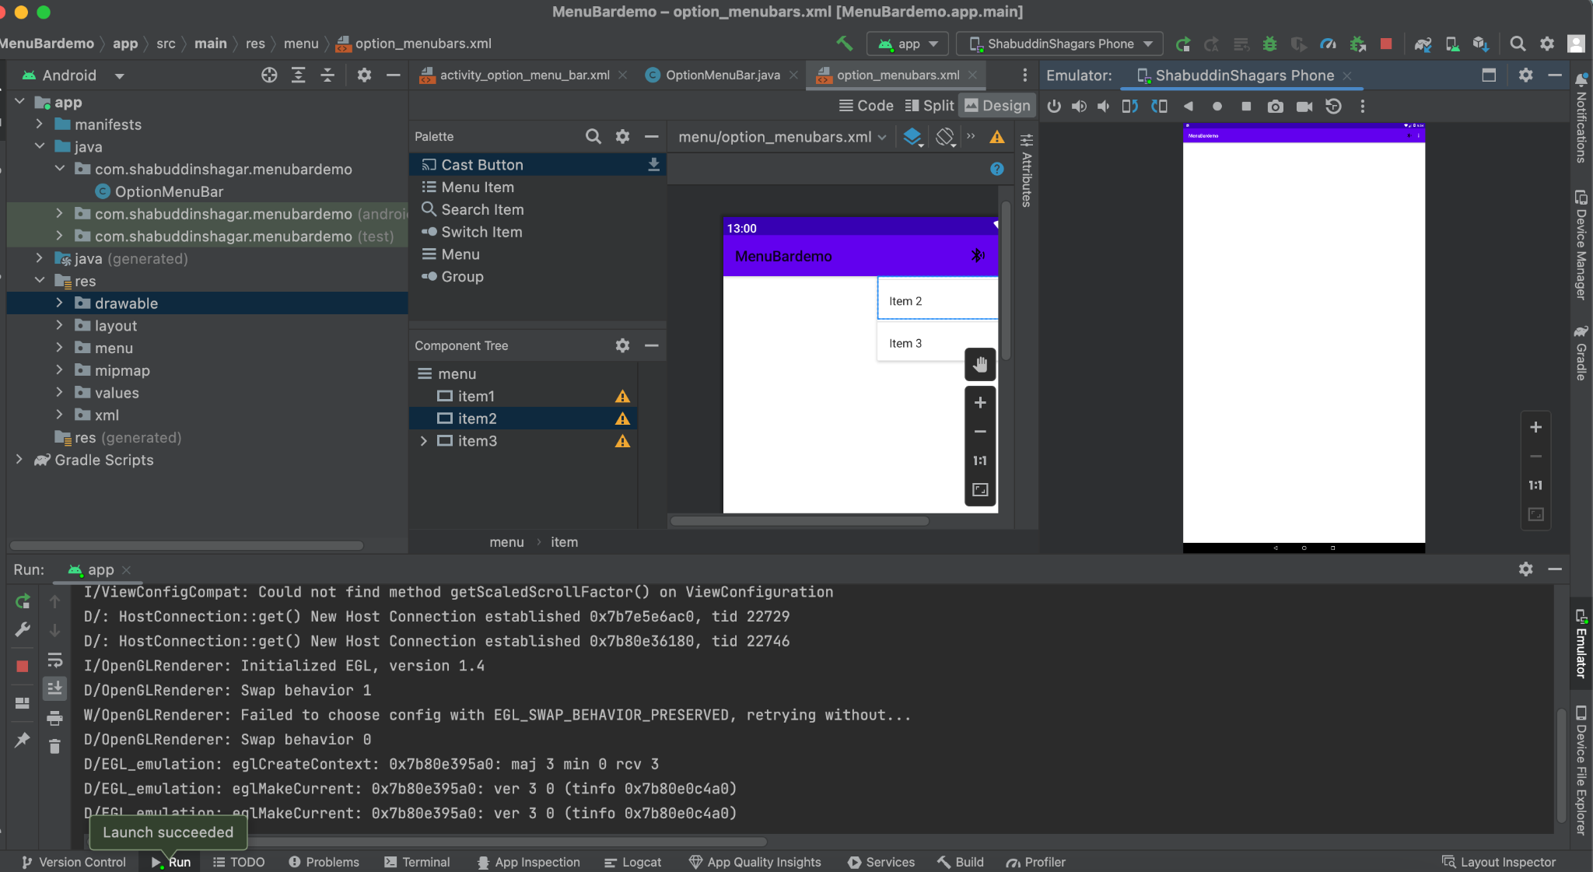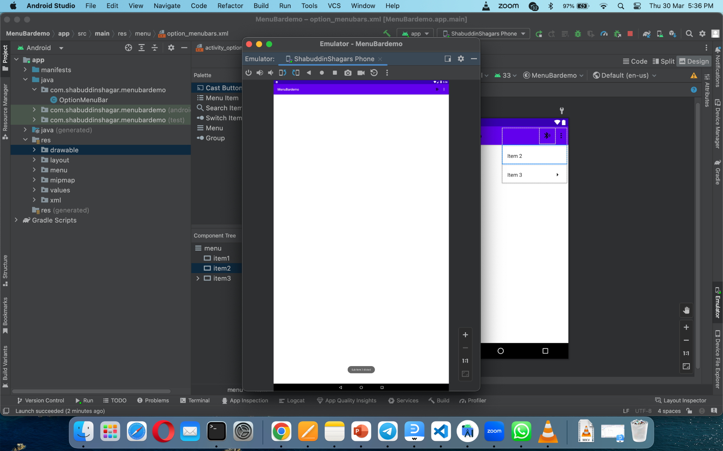

**POPUP MenuBar:**

**Activity_popup_menu_bar.xml code:**

<?xml version="1.0" encoding="utf-8"?>

<LinearLayout xmlns:android="http://schemas.android.com/apk/res/android"

xmlns:app="http://schemas.android.com/apk/res-auto"

xmlns:tools="http://schemas.android.com/tools"

android:layout_width="match_parent"

android:layout_height="match_parent"

tools:context=".PopupMenuBarDemo"

android:gravity="center">

<Button

android:id="@+id/btn1"

android:layout_width="wrap_content"

android:layout_height="wrap_content"

android:onClick="openPopUpMenuBar"

android:text="Click Me" />

</LinearLayout>

**Design:**

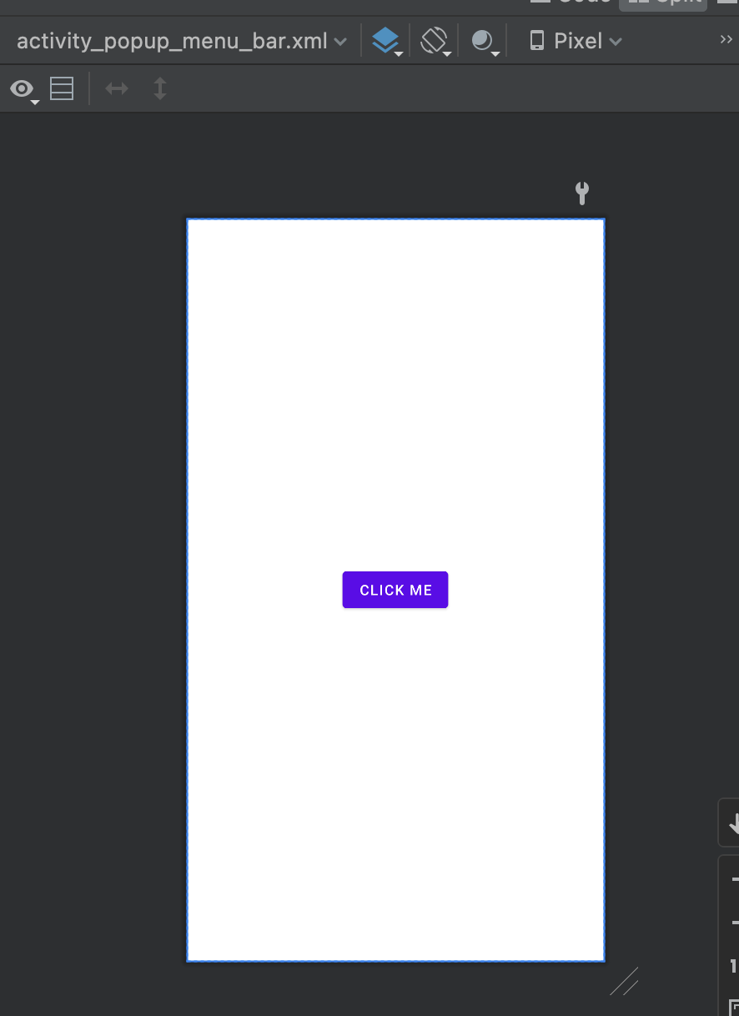

**Popup_menus.xml:**

<?xml version="1.0" encoding="utf-8"?>

<menu xmlns:android="http://schemas.android.com/apk/res/android">

<item android:id="@+id/menu_one"

android:title="Menu 1" />

<item android:id="@+id/menu_two"

android:title="Menu 2" />

<item android:id="@+id/menu_three"

android:title="Menu 3" />

</menu>

**Design:**

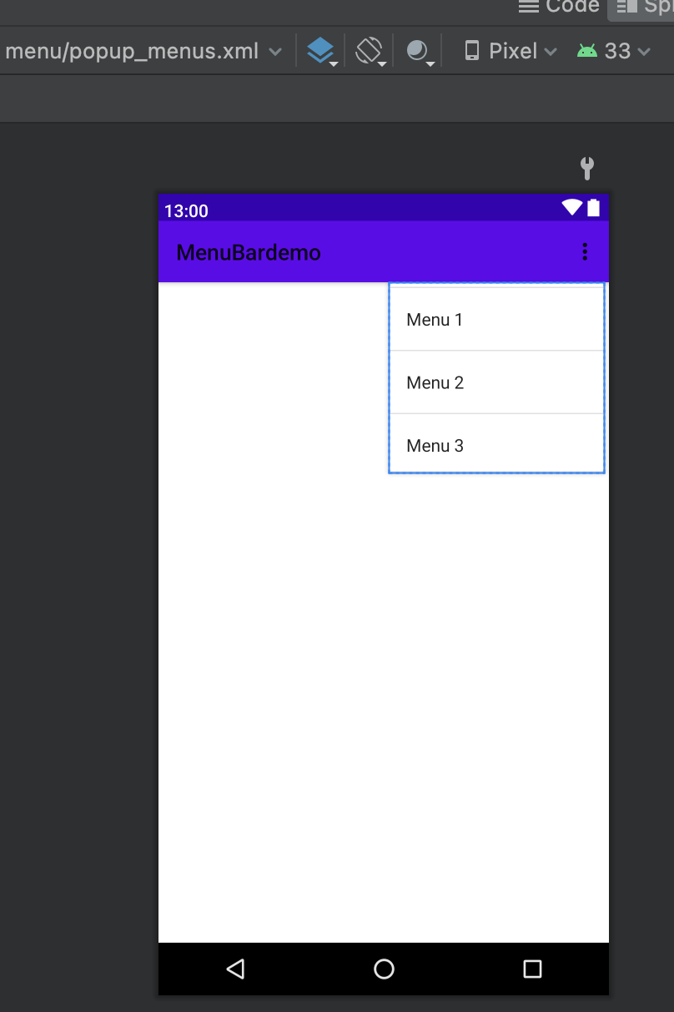

**PopupMenuBarDemo.java:**

package com.shabuddinshagar.menubardemo;

import androidx.appcompat.app.AppCompatActivity;

import android.os.Bundle;

import android.view.MenuItem;

import android.view.View;

import android.widget.Button;

import android.widget.PopupMenu;

import android.widget.Toast;

public class PopupMenuBarDemo extends AppCompatActivity {

Button btn1;

@Override

protected void onCreate(Bundle savedInstanceState) {

super.onCreate(savedInstanceState);

setContentView(R.layout.activity_popup_menu_bar);

btn1=(Button) findViewById(R.id.btn1);

}

public void openPopUpMenuBar(View view)

{

PopupMenu popupMenu=new PopupMenu( PopupMenuBarDemo.this, btn1);

popupMenu.getMenuInflater().inflate(R.menu.popup_menus, popupMenu.getMenu());

popupMenu.setOnMenuItemClickListener(new PopupMenu.OnMenuItemClickListener() {

@Override

public boolean onMenuItemClick(MenuItem item) {

MenuItem menuItem = null;

int id=menuItem.getItemId();

switch (id)

{

case R.id.menu_one:

Toast.makeText(PopupMenuBarDemo.this, "Menu 1 clicked", Toast.LENGTH_SHORT).show();

return true;

case R.id.menu_two:

Toast.makeText(PopupMenuBarDemo.this, "Menu 2 clicked", Toast.LENGTH_SHORT).show();

return true;

case R.id.menu_three:

Toast.makeText(PopupMenuBarDemo.this, "Menu 3 clicked", Toast.LENGTH_SHORT).show();

return true;

default:

Toast.makeText(PopupMenuBarDemo.this, "never", Toast.LENGTH_SHORT).show();

return true;

}

}

});

popupMenu.show();

}

}

**Output:**

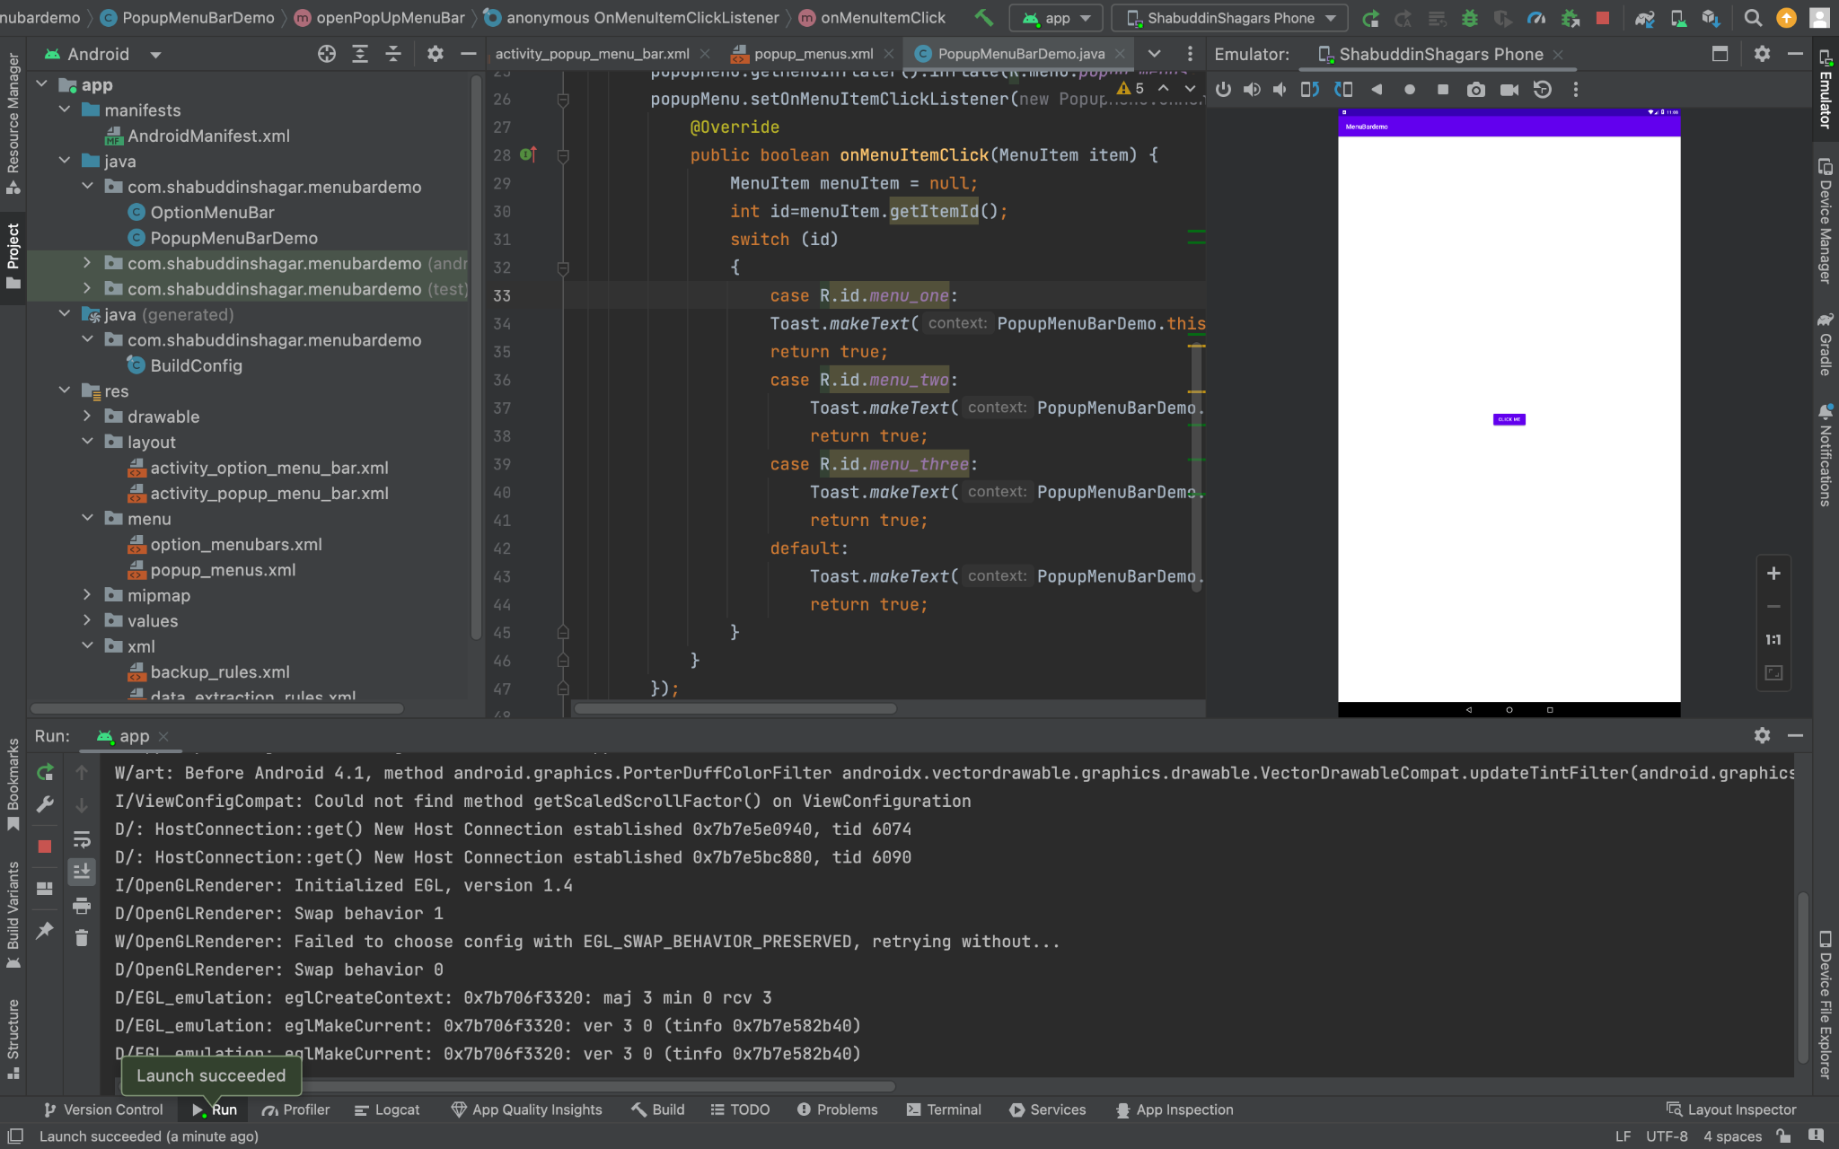

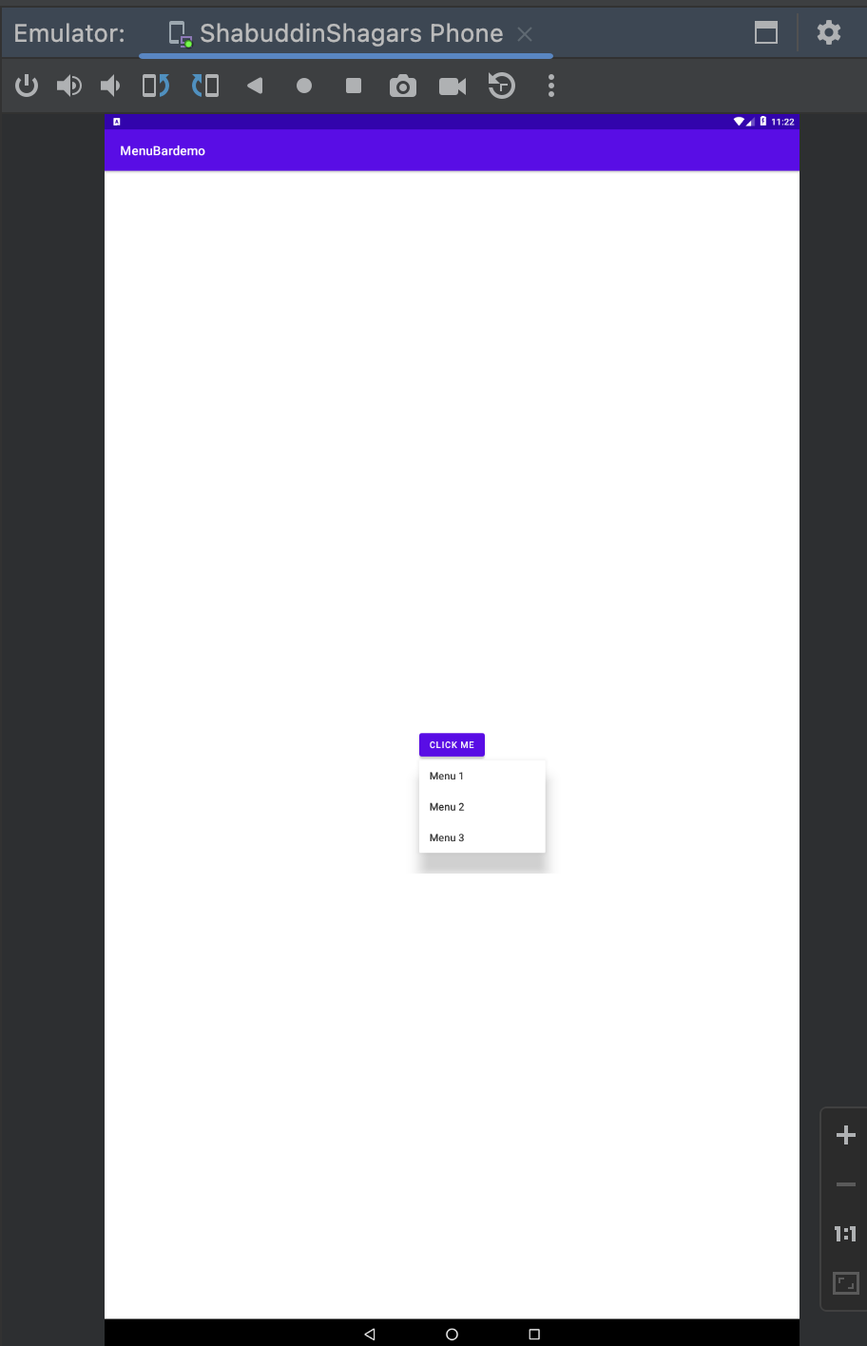

**Context Menu:**

**Activity_context_menu_bar_demo.xml:**

<?xml version="1.0" encoding="utf-8"?>

<LinearLayout xmlns:android="http://schemas.android.com/apk/res/android"

xmlns:app="http://schemas.android.com/apk/res-auto"

xmlns:tools="http://schemas.android.com/tools"

android:layout_width="match_parent"

android:layout_height="match_parent"

tools:context=".ContextMenuBarDemo">

<ListView

android:layout_width="match_parent"

android:layout_height="match_parent"

android:id="@+id/contacts_list" />

</LinearLayout>

**Design:**

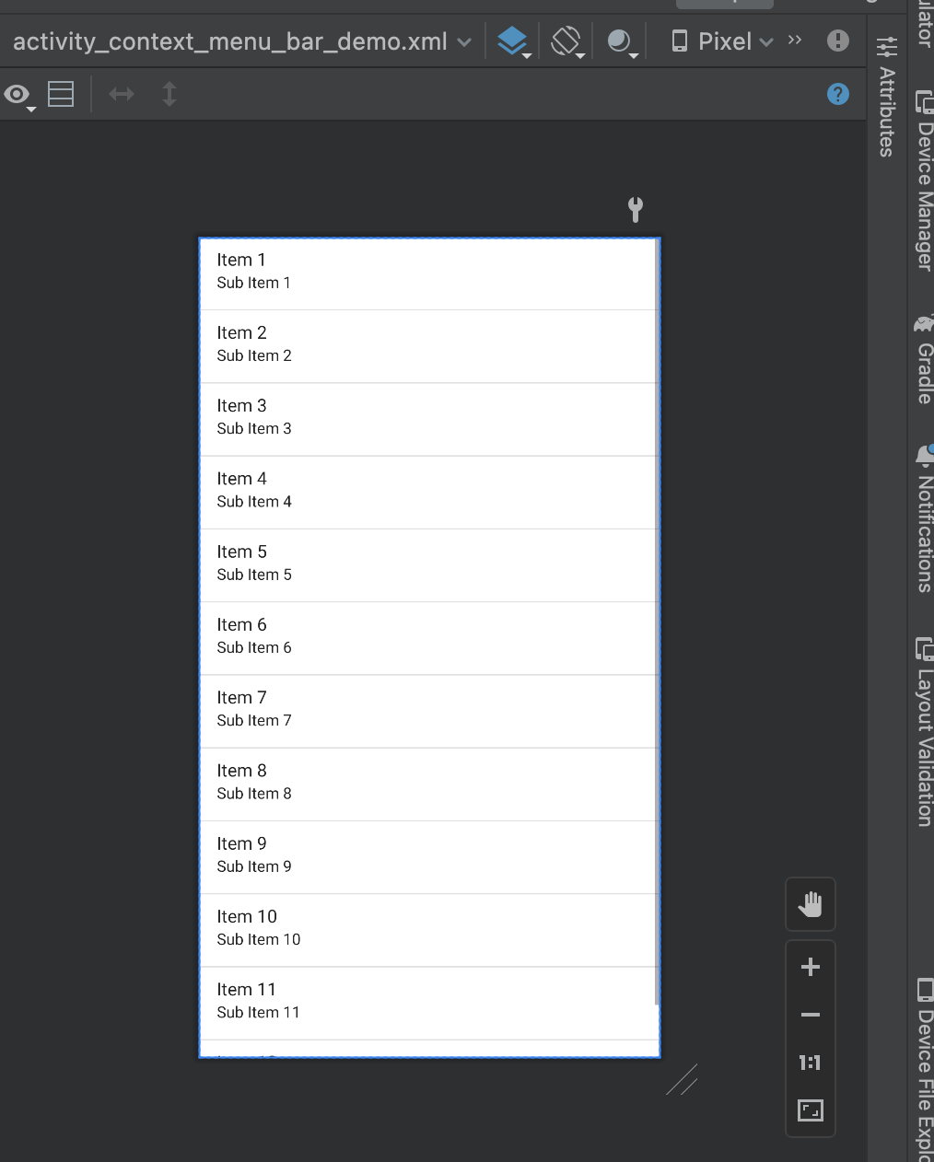

**Context_menubar.xml:**

<?xml version="1.0" encoding="utf-8"?>

<menu xmlns:android="http://schemas.android.com/apk/res/android">

<item android:id="@+id/call"

android:title="Call" />

<item android:id="@+id/message"

android:title="Message" />

</menu>

**DESIGN:**

**esign:**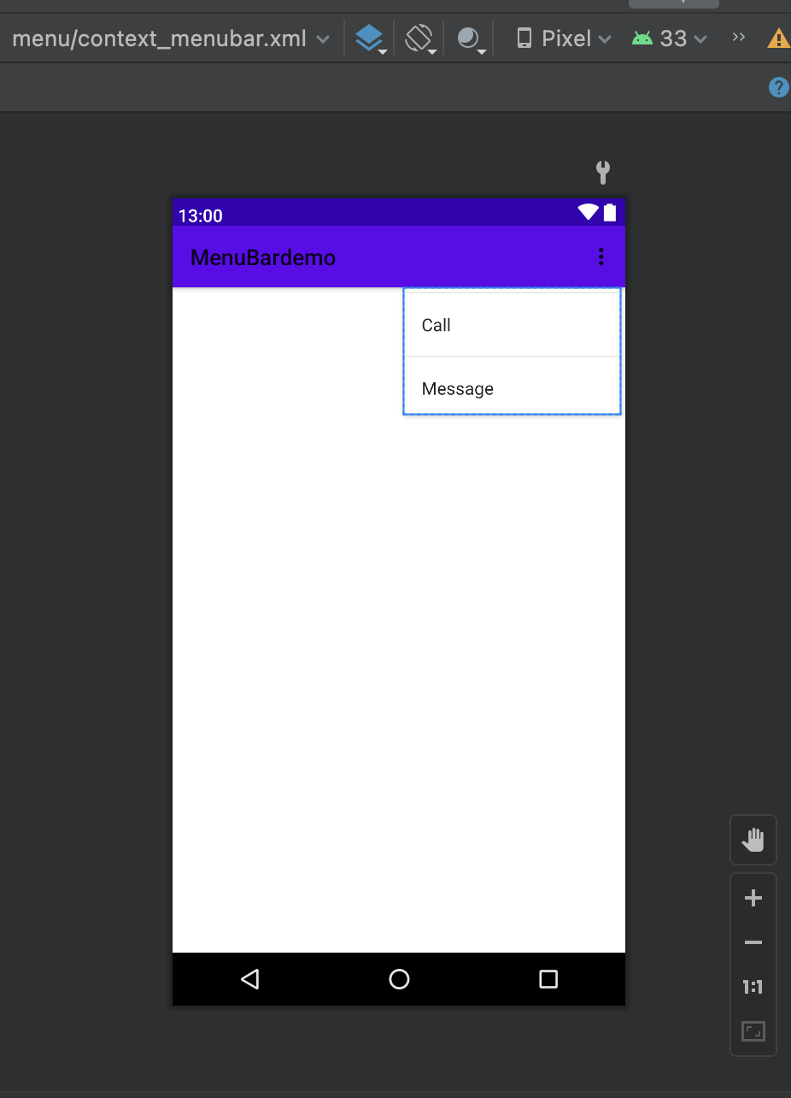

**Java Code:**

package com.shabuddinshagar.menubardemo;

import androidx.annotation.NonNull;

import androidx.appcompat.app.AppCompatActivity;

import android.os.Bundle;

import android.view.ContextMenu;

import android.view.MenuItem;

import android.view.View;

import android.widget.ArrayAdapter;

import android.widget.ListView;

import android.widget.Toast;

public class ContextMenuBarDemo extends AppCompatActivity {

ListView contacts_list;

String[] contacts = new String[]{"Shagar", "Emon", "Tonmoy", "Sayeem", "Shajid", "Zarin", "Sultana"};

@Override

protected void onCreate(Bundle savedInstanceState) {

super.onCreate(savedInstanceState);

setContentView(R.layout.activity_context_menu_bar_demo);

contacts_list=(ListView) findViewById(R.id.contacts_list);

ArrayAdapter<String> adapter = new ArrayAdapter<>(this, android.R.layout.simple_list_item_1, contacts);

contacts_list.setAdapter(adapter);

registerForContextMenu(contacts_list);

}

@Override

public void onCreateContextMenu(ContextMenu menu, View v, ContextMenu.ContextMenuInfo menuInfo) {

super.onCreateContextMenu(menu, v, menuInfo);

getMenuInflater().inflate(R.menu.context_menubar, menu);

}

@Override

public boolean onContextItemSelected(@NonNull MenuItem item) {

int id = item.getItemId();

switch (id) {

case R.id.call:

Toast.makeText(this, "calling", Toast.LENGTH_SHORT).show();

return true;

case R.id.message:

Toast.makeText(this, "message", Toast.LENGTH_SHORT).show();

return true;

default:

return super.onOptionsItemSelected(item);

}

}

}

**Output:**

